How to Install PostgreSQL and pgAdmin

Installation Instructions:

1. Windows Users:Download the Postgres Installer here:
https://sbp.enterprisedb.com/getfile.jsp?fileid=1258649

1. Mac Users:Download the Postgres Installer here:
https://sbp.enterprisedb.com/getfile.jsp?fileid=1258653

2. Double click on the downloaded file to start the installer.

3. Windows Users:If you see a pop up asking for permission to run the installer, select YES.
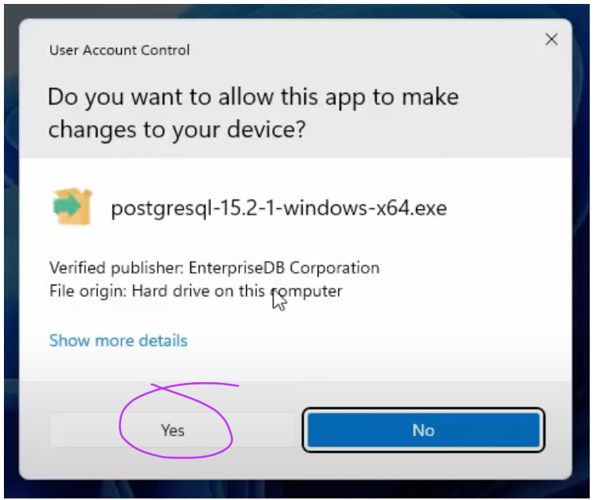

- Mac Users:If you see a pop up asking for permission to run the installer, select Open, you might need to enter your Mac password to allow the installer to run.
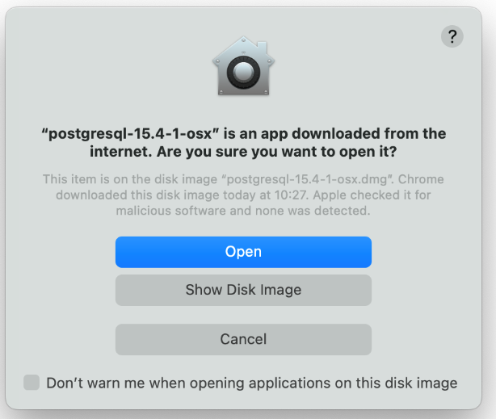
- ClickNext to continue through the installer, until you reach this pane and make sure that everything is selected especially pgAdmin.
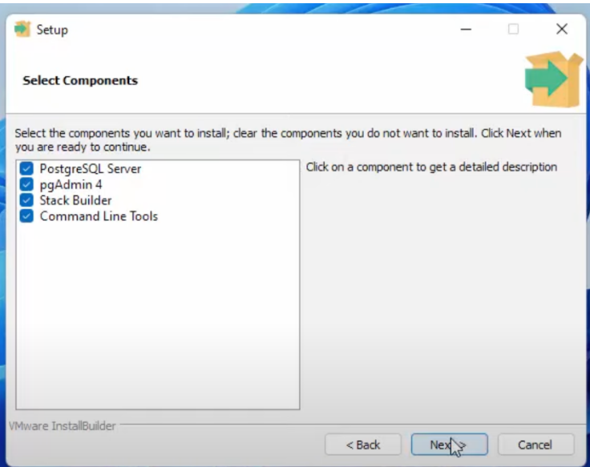

- Continue clickingNext until you reach this screen. Your superuser username is postgres and you need to set a password. Make sure you write this password down. We will need this later to access our database.
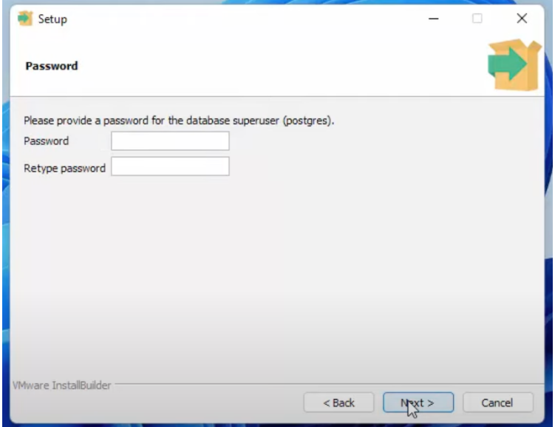
6. Continue through the installer, leave everything as the default and just keep clicking Next. Once installation completes then you're done you can click Finish and you can continue to the next lesson!

NOTE: If Stack Builder launches after installation completes, just close it. We will be doing everything from scratch together in the next lesson without using a wizard.

